1. A mass of 200 g of saturated liquid water is completely vaporized at a constant pressure of 100 kPa. Determine (a) the volume change and (b) the amount of energy transferred to the water.
2. A rigid tank contains 10 kg of water at 90°C. If 8 kg of the water is in the liquid form and the rest is in the vapor form, determine (a) the pressure in the tank and (b) the volume of the tank
3. Determine the temperature of water at a state of P = 0.5 MPa and h = 2890 kJ/kg.
4. A piston/cylinder arrangement is loaded with a linear spring and the outside atmosphere. It contains water at 5 MPa, 400*◦*C, with the volume being 0.1 m3, as shown in Figure. If the piston is at the bottom, the spring exerts a force such that *P*lift=200 kPa. The system now cools until the pressure reaches 1200 kPa. Find the mass of water and the final state (*T*2, *v*2) and plot the *P*–*v* diagram for the process.

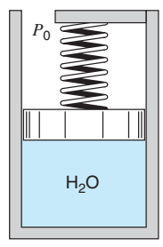 **Q.4 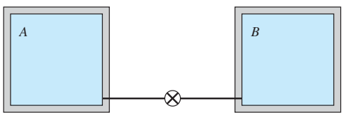 Q.5**

1. Two tanks are connected as shown in Q.5 , both containing water. Tank A is at 200 kPa, v = 0.5 m3/kg, VA = 1 m3, and tank B contain 3.5 kg at 0.5 MPa and 400◦C. The valve is now opened and the two tanks come to a uniform state. Find the final specific volume.
2. One kilogram of water vapor at 200 kPa fills the 1.1989-m3 left chamber of a partitioned system shown in Q.6. The right chamber has twice the volume of the left and is initially evacuated. Determine the pressure of the water after the partition has been removed and enough heat has been transferred so that the temperature of the water is 3°C.

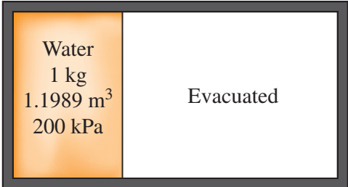 **Q.6 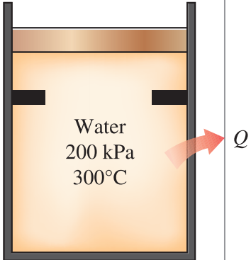Q.7 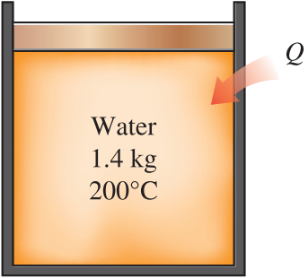 Q.8**

1. Water initially at 200 kPa and 300°C is contained in a piston–cylinder device fitted with stops. The water is allowed to cool at constant pressure until it exists as a saturated vapor and the piston rests on the stops. Then the water continues to cool until the pressure is 100 kPa. On the T-v diagram, sketch, with respect to the saturation lines, the process curves passing through the initial, intermediate, and final states of the water. Label the T, P, and v values for end states on the process curves. Find the overall change in internal energy between the initial and final states per unit mass of water.
2. A piston–cylinder device initially contains 1.4 kg saturated liquid water at 200°C. Now heat is transferred to the water until the volume quadruples and the cylinder contains saturated vapor only. Determine (a) the volume of the cylinder, (b) the final temperature and pressure, and (c) the internal energy change of the water.
3. A piston–cylinder device initially contains 50 L of liquid water at 40°C and 200 kPa. Heat is transferred to the water at constant pressure until the entire liquid is vaporized. (a) What is the mass of the water? (b) What is the final temperature? (c) Determine the total enthalpy change. (d) Show the process on a T-v diagram with respect to saturation lines.
4. A rigid tank initially contains 1.4 kg saturated liquid water at 200°C. At this state, 25 percent of the volume is occupied by water and the rest by air. Now heat is supplied to the water until the tank contains saturated vapor only. Determine (a) the volume of the tank, (b) the final temperature and pressure, and (c) the internal energy change of the water.
5. 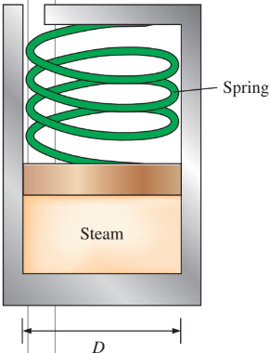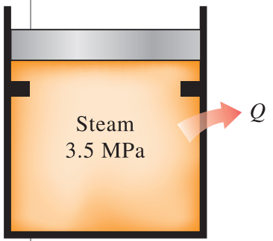The spring-loaded piston–cylinder device shown in Q.11 is filled with 0.5 kg of water vapor that is initially at 4 MPa and 400°C. Initially, the spring exerts no force against the piston. The spring constant in the spring force relation F = kx is k = 0.9 kN/cm and the piston diameter is D = 20 cm. The water now undergoes a process until its volume is one-half of the original volume. Calculate the final temperature and the specific enthalpy of the water.

**Q.11** **Q.12**

1. A piston–cylinder device initially contains 0.35 kg of steam at 3.5 MPa, superheated by 5°C. Now, steam loses heat to the surroundings and the piston moves down, hitting a set of stops, at which point the cylinder contains saturated liquid water. The cooling continues until the cylinder contains water at 200°C. Determine (a) the initial temperature, (b) the enthalpy change per unit mass of the steam by the time the piston first hits the stops, and (c) the final pressure and the quality (if mixture).